
CALCULUS
CALCULUS
Sonu Memon’s NoteBook
ABDUL HASEEB MEMON


Core Mathematical Concepts for ML, DL, Agentic AI & Robotics
------ Robotics & Agentic Ai Enthusiast ------

CALCULUS
It is basically a branch of Mathematics that deals with the Continuous Change of any thing. In general, it is a Science behind specific continuous Change.
Invented by:
Isaac Newton (1665) & Gottfried Wilhelm Leibniz (1670 – 1684).
Purpose:
- The main purpose of Calculus was to understand the Continuous Change of any motion as Continuity will be possible when we evaluate / examine the behavior of any object that is in motion. And then this great impactful concept of calculus came across at the portrait so, that we easily figure out the specific change and measure that change through mathematically by using such techniques of calculus.
- It is used to Study those Curves who has not a linear behavior means their slope changes at every point / position.
- Motions = growth, speed, economy, curve, area, motion, etc.
Techniques / Parts / Types of Calculus:
- Differential Calculus: how fast the behavior of continuous object / thing is Changing.
- Integral Calculus: It clarifies how much total change is happened or total change is accumulated.
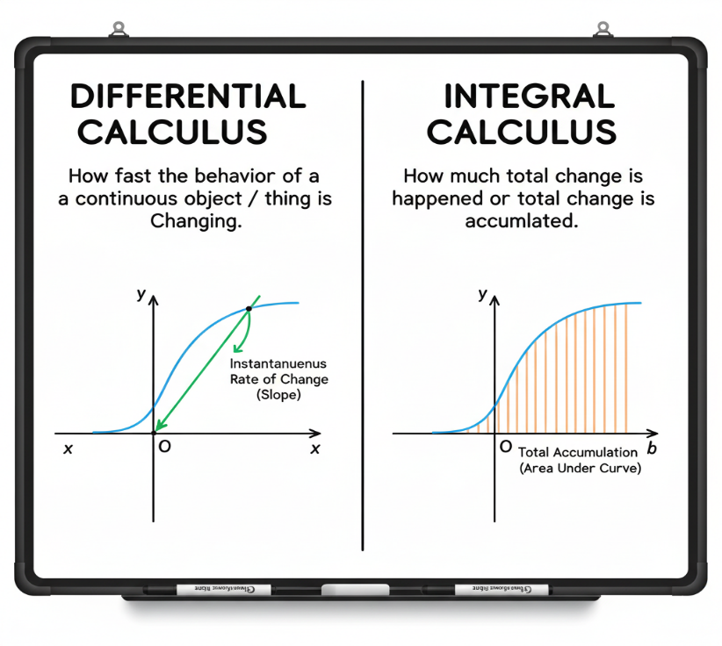
Function
It is like a Machine that takes some input and then performs specific actions on it to produce one output. OR Rules that assigns any input to produce exactly one output.
Input chooses the situation.
Output is the quantity we operate on.
Purpose:
- The identification of specific continuous change seen inside the function so, that’s why Scientist & Experts have to measure the change than they introduce such techniques to evaluate that particular change that is seen in Operations of Function.
- To convert any input in a predictable Output.
Functions Notation: f(x)
- To write any function in a shorthand manner.
- To show the relationship of input & output in a clean & better way.
Eg: f(x) = 3x²
Basic Terms in Functions:
- Domain → input ({1, 2, 3})
- Codomain → possible outputs ({a, b, c, d})
- Mapping → the linkage b/w i/p & o/p (1 → a, 2 → b, 3 → c)
- Range → actual outputs ({a, b, c})
- Pre-image → where output came from (Pre-image of b = 2)
- Post-image → where input goes (post-image of 2 = b)
Pictorial (View):
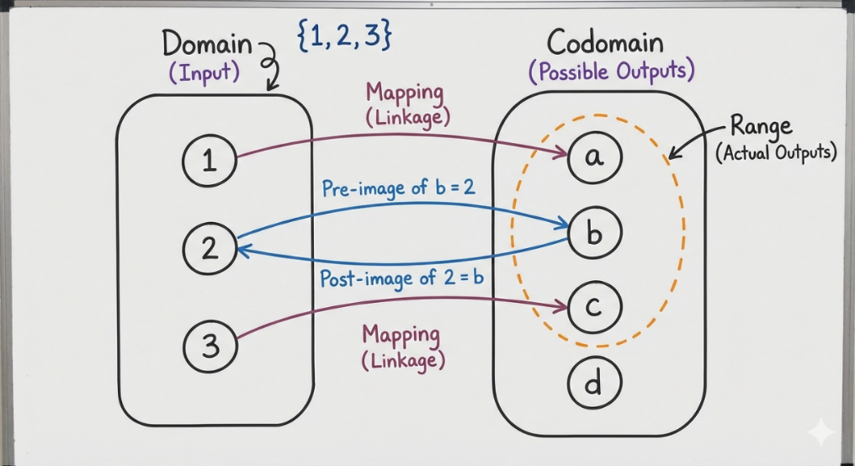
Kinds of Functions:
- Into:
Into function when there are some unused elements left behind in Co Domain OR Mapping that leaves some outputs unused. OR if at least one element of the codomain has no pre-image in the domain.
Analogy
Some seats in the classroom remain empty after students sit.
Pictorial (VIEW)
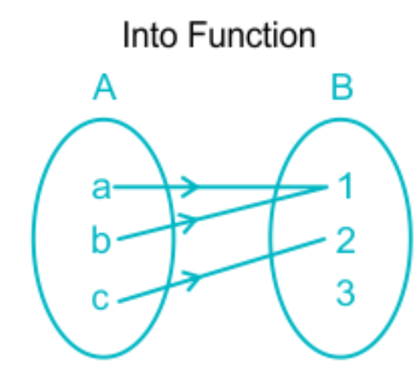
- Onto (Surjective):
In this Every Element of Co Domain is Covered and there is no one left behind.
Analogy
Every seat in the classroom is occupied by at least one student.
Pictorial (VIEW)
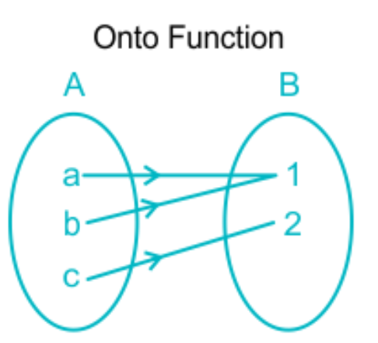
- One-One (Injective):
In this every input has distinct output & there is uniqueness in this Function, means the Co Domain elements in Range never repeat.
Analogy
Roll no (unique) (no two students share one roll number).
Pictorial (VIEW)
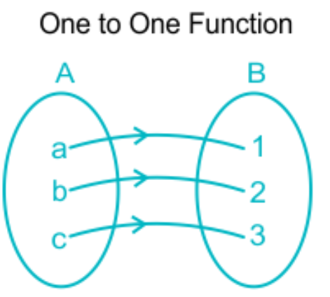
- Bijective:
One- One + Onto (Combination) is Bijective Function. (every o/p has any input Onto = ) (Every input has unique o/p One-One = ) So, + = forward + Backward/ Reverse (Now here it balances the forward & Reverse mapping).
Analogy
Each student has exactly one unique seat, and every seat has exactly one student.
Pictorial (VIEW)
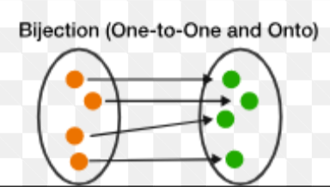
Types of Function:
- Linear Function:
Any Straight-line functions that follow f(x) = mx + b.
Purpose: To represent a constant rate of change.
Use: Speed, Cost, temperature Change etc.…
Eg: f(x) = 5x+3
Analogy: In every second the bike having a same speed.
- Quadratic Function:
Any Parabolic Curve that follows f(x) = ax² + bx + c.
Purpose: To represent a turning points & Curves.
Use: Projectile Motion, torque, profit-Loss etc.
Eg: x² – 4x + 3
Analogy: Find the Arc of thrown ball.
- Polynomial Function:
A polynomial is a function with x raised to whole-number powers (like x, x², x³) combined with + & -. Each term with a power of x has its own individual constant (coefficient).
Purpose: To represent & model the complex Curves.
Use: Engineering, Optimization, Physics etc.
Eg: f(x) = 4x³ – 2x + 7
Analogy: A polynomial is like a smoothie made by mixing different fruits (powers of x) in different amounts (constants).
- Exponential Function:
An exponential function is a function in which the variable (x) is in the exponent (power). (Increase of one thing (powered) ultimately leads to increase in faster resultant).
Purpose: to represent and model Fast growth/decay
Use: Compound Interest, Population, Virus etc.
Eg: f(x) = 2^{x}
Analogy: We see viral videos suddenly boom as the algorithm behind it works on exponential function as the amount of time that algorithms take always Exponential.
- Logarithmic Function:
A logarithmic function is the inverse of an exponential function. it tells you the power needed to reach a number. (Logarithmic Functions make measurable the Exponential Functions also.)
Purpose: to manage the Large Values as actually it predicts how many times specific number is divided in subunits to solve large values
Use: Earthquakes, Sound intensity, PH, etc.
Eg: f(x) = log₁₀ x
Analogy: To Zoom out the image to make image frame smaller to see exact image more accurately.
- Trigonometric Function:
It tells the relationship b/w the angle-based functions’ behavior in the graph. Trigonometric functions describe how angles relate to the behavior of sine, cosine, tangent, and other angle-based curves on a graph. & They show how angles change the shape of the sine, cosine, and tangent graphs.
Purpose: to represent & model the rotations, cycles, waves behaviors.
Use: Engineering, Graphics, wave(physics), etc.
Eg: f(x) = sin x
Analogy: Swing behavior of Pendulum Up & Downs.
- Inverse Function:
It simply Reverses the mapping of input & Output
Purpose: recover original input.
Use: Cryptography, Math, Solving etc.
Eg: f(x) = x + 3 → f⁻¹(x) = x – 3
Analogy: Just like an Undo Button that restores the previous State.
- Nested Function:
Function inside another functions f(x), g(x) → f(g(x))
Purpose: to perform step by step transformation for ML.
Use: ML Pipelines, Math, Programming etc.
Eg: f(x)=x², g(x)=x+1 → f(g(x)) = (x+1)²
Analogy: Outer envelope = outer function, inner envelope = inner function, letter = actual computation/result.
- Ceiling Function:
Function gives the smallest integer greater than or equal to x.
Purpose: to force a value up to the nearest integer.
Use: Minimum required resource, capacity planning, deadlines.
Eg: ⌈3.7⌉ = 4, ⌈−2.3⌉ = −2
Analogy: You look up in a building ceiling tells you the next floor above you.
- Floor Function:
Function gives the greater integer smaller than or equal to x.
Purpose: To force a value down to the nearest integer.
Use: Rounding down in billing, scheduling, computer science
Eg: ⌊3.7⌋ = 3, ⌊−2.3⌋ = −3
Analogy: You are between floors floor tells you which floor you are standing on.
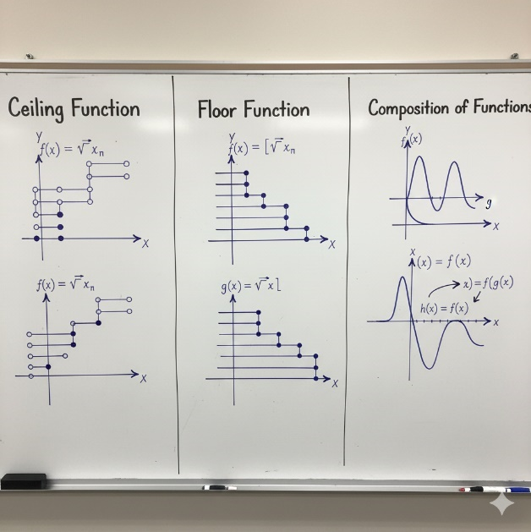
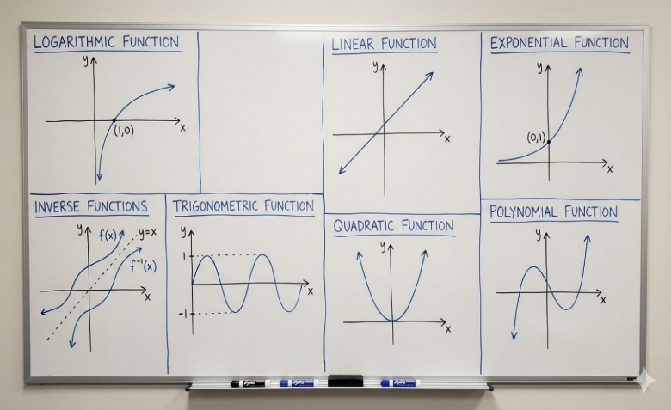
Pictorial (VIEW)

OPERATIONS ON FUNCTIONS
- Addition of Functions
Add the outputs of two functions.
Purpose: Find the combined effect.
Use: Total cost, combined signals.
Example: f(x)=x, g(x)=2x → (f+g)(x)=3x
Analogy: Two people working together.
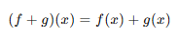
- Subtraction of Functions
Subtract one function’s output from another.
Purpose: Find the difference.
Use: Profit = revenue − cost.
Example: f(x)=5x, g(x)=2x → (f−g)(x)=3x
Analogy: Expenses removed from income.
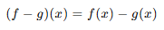
- Multiplication of Functions
Multiply the outputs of two functions.
Purpose: Show interacting effects.
Use: Area, physics formulas.
Example: f(x)=x, g(x)=x+1 → x(x+1)
Analogy: Teamwork multiplies results.
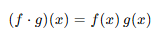
- Division of Functions
Divide the output of one function by another (denominator ≠ 0).
Purpose: Find ratios.
Use: Speed = distance ÷ time.
Example: f(x)=x², g(x)=x → x
Analogy: Sharing pizza per person.
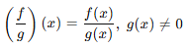
- Scalar Multiplication
Multiply a function by a constant.
Purpose: Scale the output.
Use: Signal amplification.
Example: 2f(x)=2x
Analogy: Increasing volume.
- Scalar Addition
Add a constant to the function output.
Purpose: Shift the graph up or down.
Use: Calibration adjustment.
Example: x² + 3
Analogy: Elevator moving up.
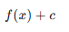
- Composition of Functions
Apply one function inside another.
Purpose: Perform step-by-step transformation.
Use: Programming pipelines, machine learning.
Example: f(x)=x², g(x)=x+1 → (x+1)²
Analogy: teacher A check MCQS, teacher B checks Theory & than combined result.
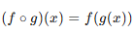
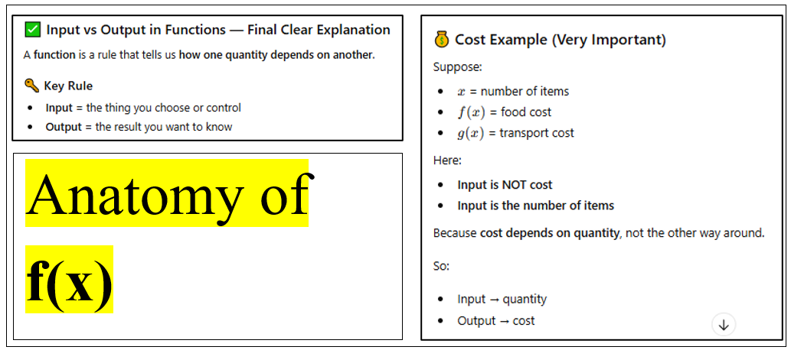
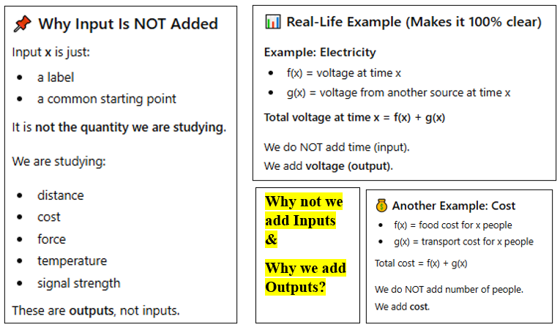
CONCEPTUAL FRAGMENTS: WHY?

LIMITS
Limit in Conceptual perspective, its approaching value not a touching it means it is a toll that tells us how we reach that instant (derivative (rate of change of an instant)). Change is the distance b/w two points or a slope with respect to diffference of base axis or dimension So, rate of that particular change is simply considered to seen when we implement the limit if we change one value what is the change and where it is approaches towards.
Formula:
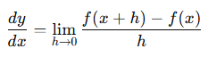
Purpose:
- it is a Smooth real time control for specific inputs that are processing in function (machine).
- Measure instant speed
- Find slopes at a point
- Model continuous change
- Build derivatives
- Enable learning & control systems
- No limits = no calculus = no ML gradients = no robotics control.
Analogy:
Robot Arm Motion: A robot arm:
Moves smoothly. Needs instant velocity & acceleration
Limit meaning in robotics:
“What is the arm’s speed at this exact micro-moment?”
Without limits:
- Motion becomes jerky
- Control systems fail
- Balance & precision collapse
- Limit = smooth real-time control

CONTINUITY
Limit tells where a function is going; continuity confirms it reaches there.
A function is continuous at a point if the value of the function and the value approached by the function at that point are the same.
Formula:
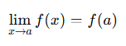
Analogy:
Road & Destination
Limit:
The road leads towards Karachi
Continuity:
You arrive in Karachi
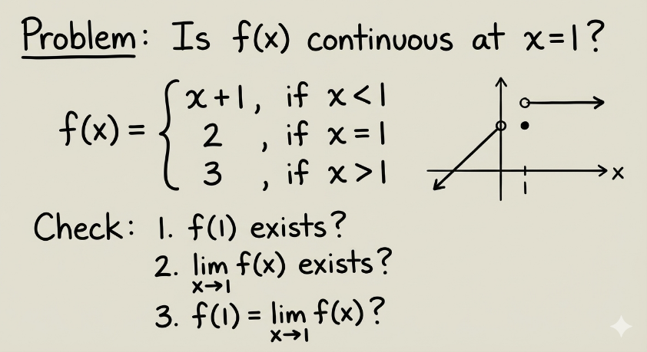
Concept:
- Limit → direction / destination
- Continuity → arrival confirmation
- Limit = intention
- Continuity = execution

DISCONTINUITY:
A function is discontinuous at a point if it breaks, jumps, or fails to match its approaching value at that point.
- Breaks: Function suddenly stops or is undefined at a point; happens where the graph has a gap.
- Jump: Function value jumps to a different number; happens when left-hand and right-hand limits differ.
- Removable Hole: Limit exists but function value is missing or different; happens when there is a hole in the graph.
- Infinite: Function value goes to infinity near a point; happens near vertical asymptotes
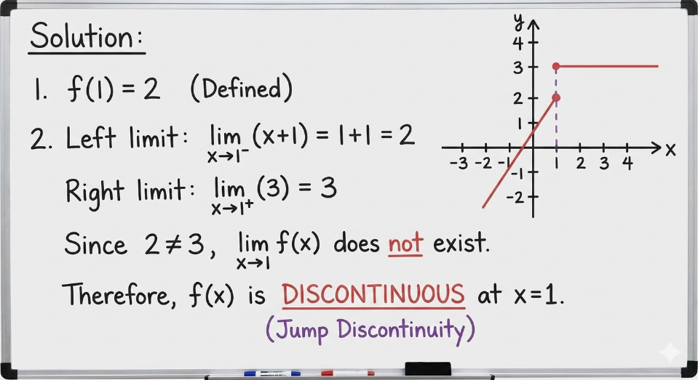

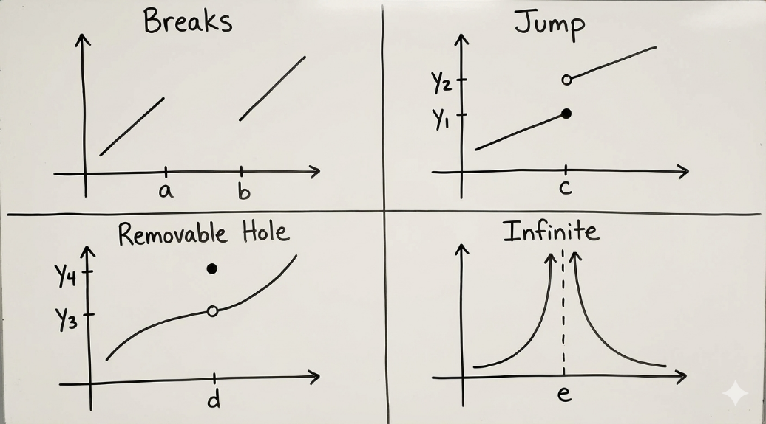

DERIVATIVE
Derivative tells how fast a quantity changes when the input changes. AND Derivative of a function at a point is the rate of change of output with respect to input.
SOME CONFUSIONS
A function is a rule,
but the output value represents a quantity (distance, temperature, cost, position, etc.).
We say “quantity” in derivatives because functions model real-world quantities, and derivatives measure how those quantities change, not just their numerical values
Value → just a number
Quantity → a number with meaning + unit
Formula: by definition
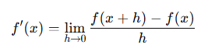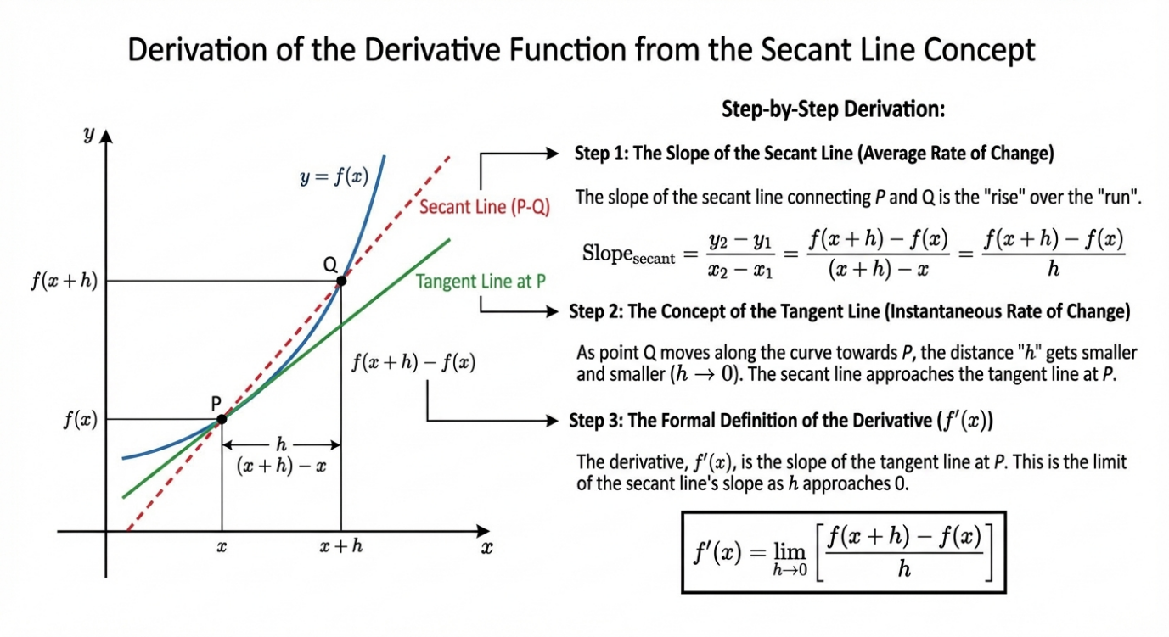
Notations:
- Lagrange Notation (using a prime mark): f’(pronounced "f prime of x")
- Leibniz Notation (using ratios): dy/dx
Power Rule:
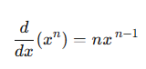
Derivative of Constant:
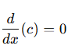
Constant Multiple Rule:
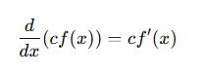
Sum / Difference Rule:
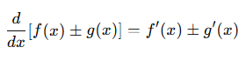
Some Standard:
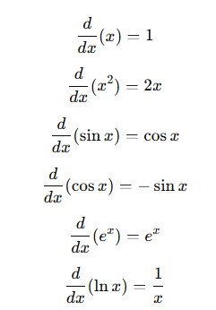
PROPERTIES OF DERIVATIVE
- Power Rule
If a variable is raised to a power, the rate of change comes from reducing the power by 1.
Purpose: Quickly differentiate polynomial terms
Use: Single-term powers like X^{n}
Constraint: Works only when exponent is constant
Formula:
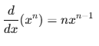

Eg:
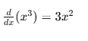
- Product Rule
When output depends on two multiplying functions, both affect the change.
Purpose: Handle multiplication of functions
Use: f(x)⋅g(x)
Constraint: Only for products
Formula:
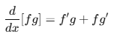
Eg:
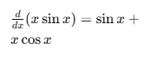
- Quotient Rule
When output is a ratio, numerator and denominator compete in change.
Purpose: Handle division of functions
Use: f(x)/g(x)
Constraint: Only for division, Denominator ≠ 0
Formula:
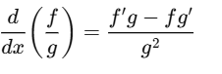
Eg:
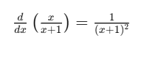

- Chain Rule
Change flows through layers: outer change × inner change.
Purpose: Differentiate nested functions
Use: f(g(x))
Constraint: Must be composition (inside function)
Formula:
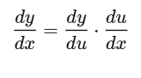
Eg:
